Today a few enhancements were made to the Rev. 3 filter that was discussed in the last document. These improvements were measured on the VNA in the LID. The goal was to improve two areas of the filter. First, the center frequency of the pass band needs to be improved to match 436.5 MHz. Second, the S11 response of the filter needs improved.

To improve the center frequency of the filter, the inductor, L1, in the elliptical section of the filter was removed an exchanged with one with a larger inductance. First, the inductor is increased from 15nH to 16nH, which is a fairly modest increase. Here, little change was observed on the VNA. Of note, the inductors on the board have a 5% tolerance, and therefore, the 1nH change was most likely not significant enough to make a measureable difference. Next an 18nH inductor was used. Here, a noticeable shift in frequency was noted, but the second harmonic was no longer properly attenuated. Cautioned by the 2nd harmonic response, the 15nH inductor was replaced and the filter tuning based on L1 was abandoned.

Next, the 15pF capacitor located at the beginning of the elliptical filter was removed. Simulation had demonstrated that varying this capacitor over a small range had absolutely no effect on the “dip” created by the elliptical filter that we are using to attenuate the 2nd harmonic. This capacitor seemed like a prime suspect for tuning. In simulation, 12pF seemed to work really well, so this is the value chosen to replace the 15pF cap. To satisfaction, the change in capacitance not only improved the impedance of the filter, it also located the 436.5 MHz signal closer to the center of the pass band.

Below is an image of the response of the filter after this modification. The S11 parameter has improved to -22dB and the S21 parameter is less than a dB down. A quick back-of-the-napkin calculation shows that the filter is passing about 90% of the signal.

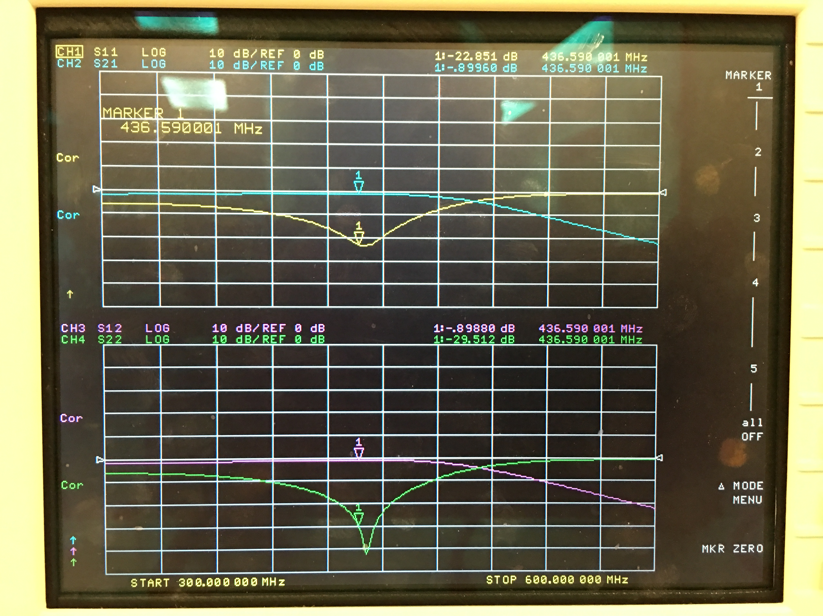

Figure 1. Response of rev. 4 filter after capacitor change

The following image shows the attenuation of the second harmonic. At -42dB, the filter is functioning pretty well. This attenuation could be improved, however.

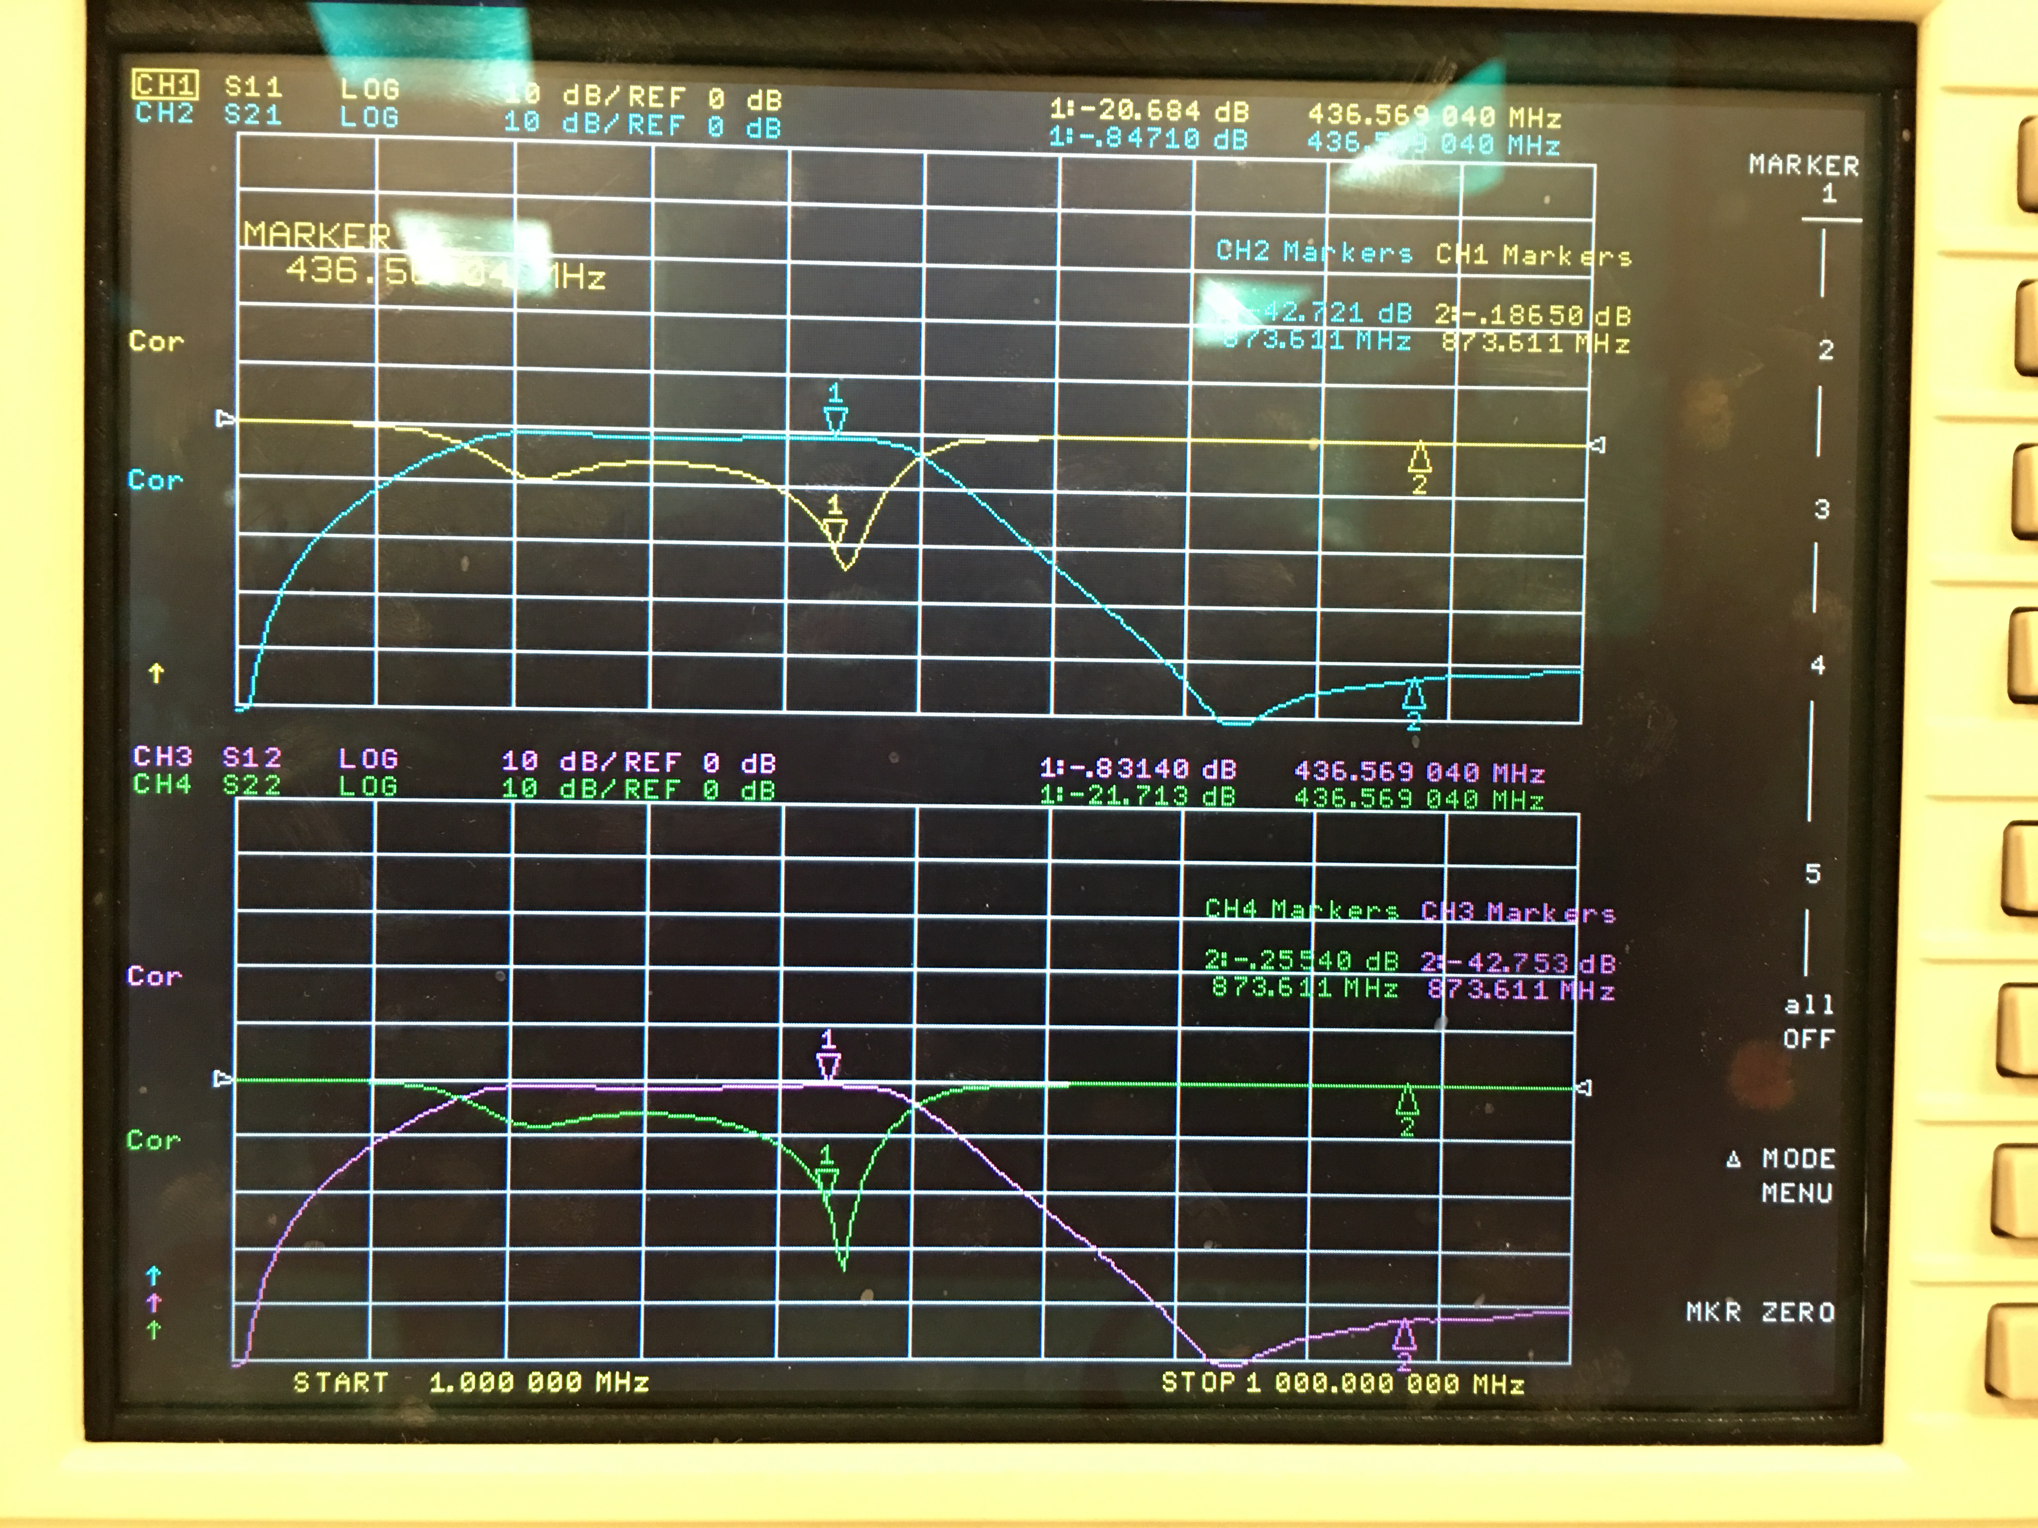

Figure 2 . Response of rev. 4 filter after capacitor change showing pass band and 2nd harmonic